Video 1:

Video 2:

Video 3:

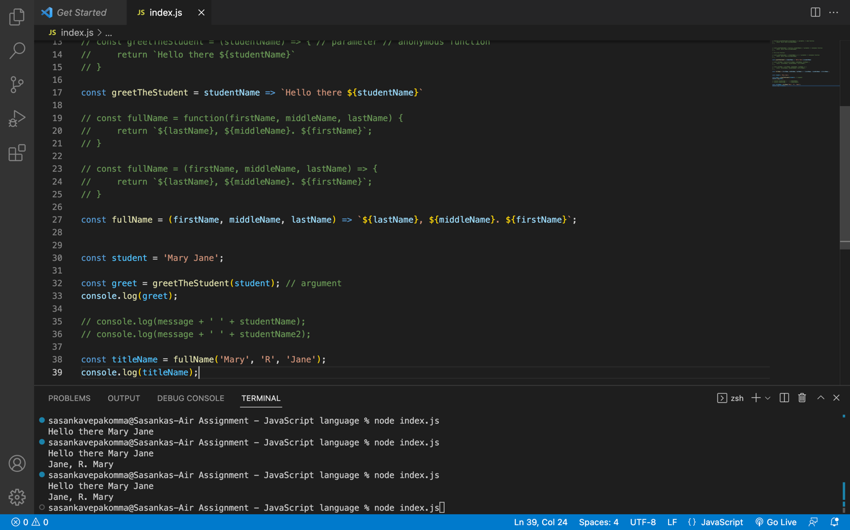

Video 4:

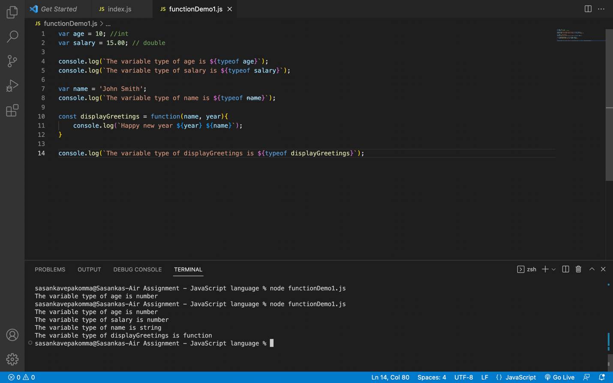

Video 5:

Video 6:

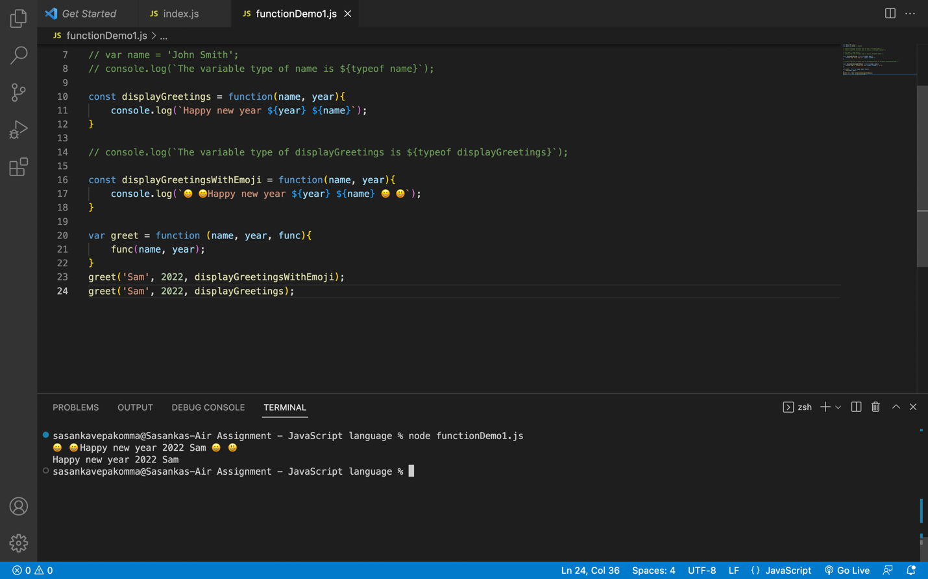

Video 8:

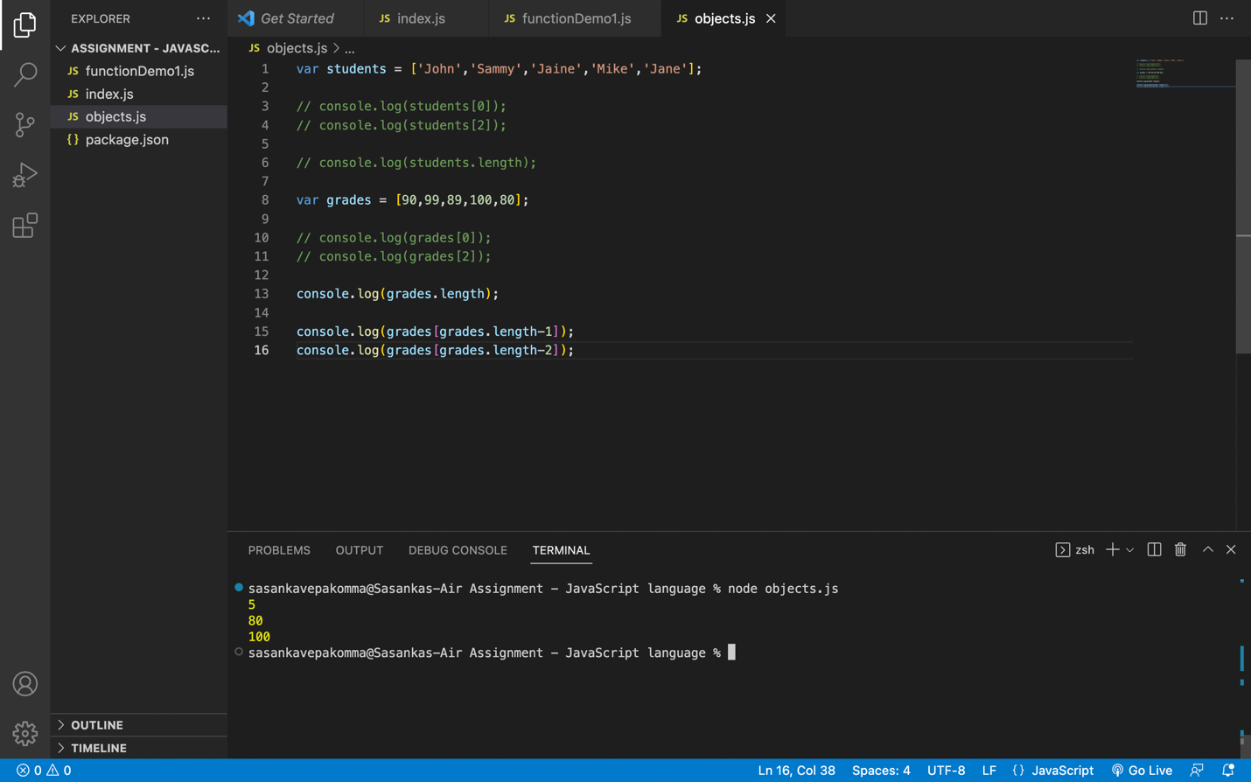

Video 9:

Video 10:

